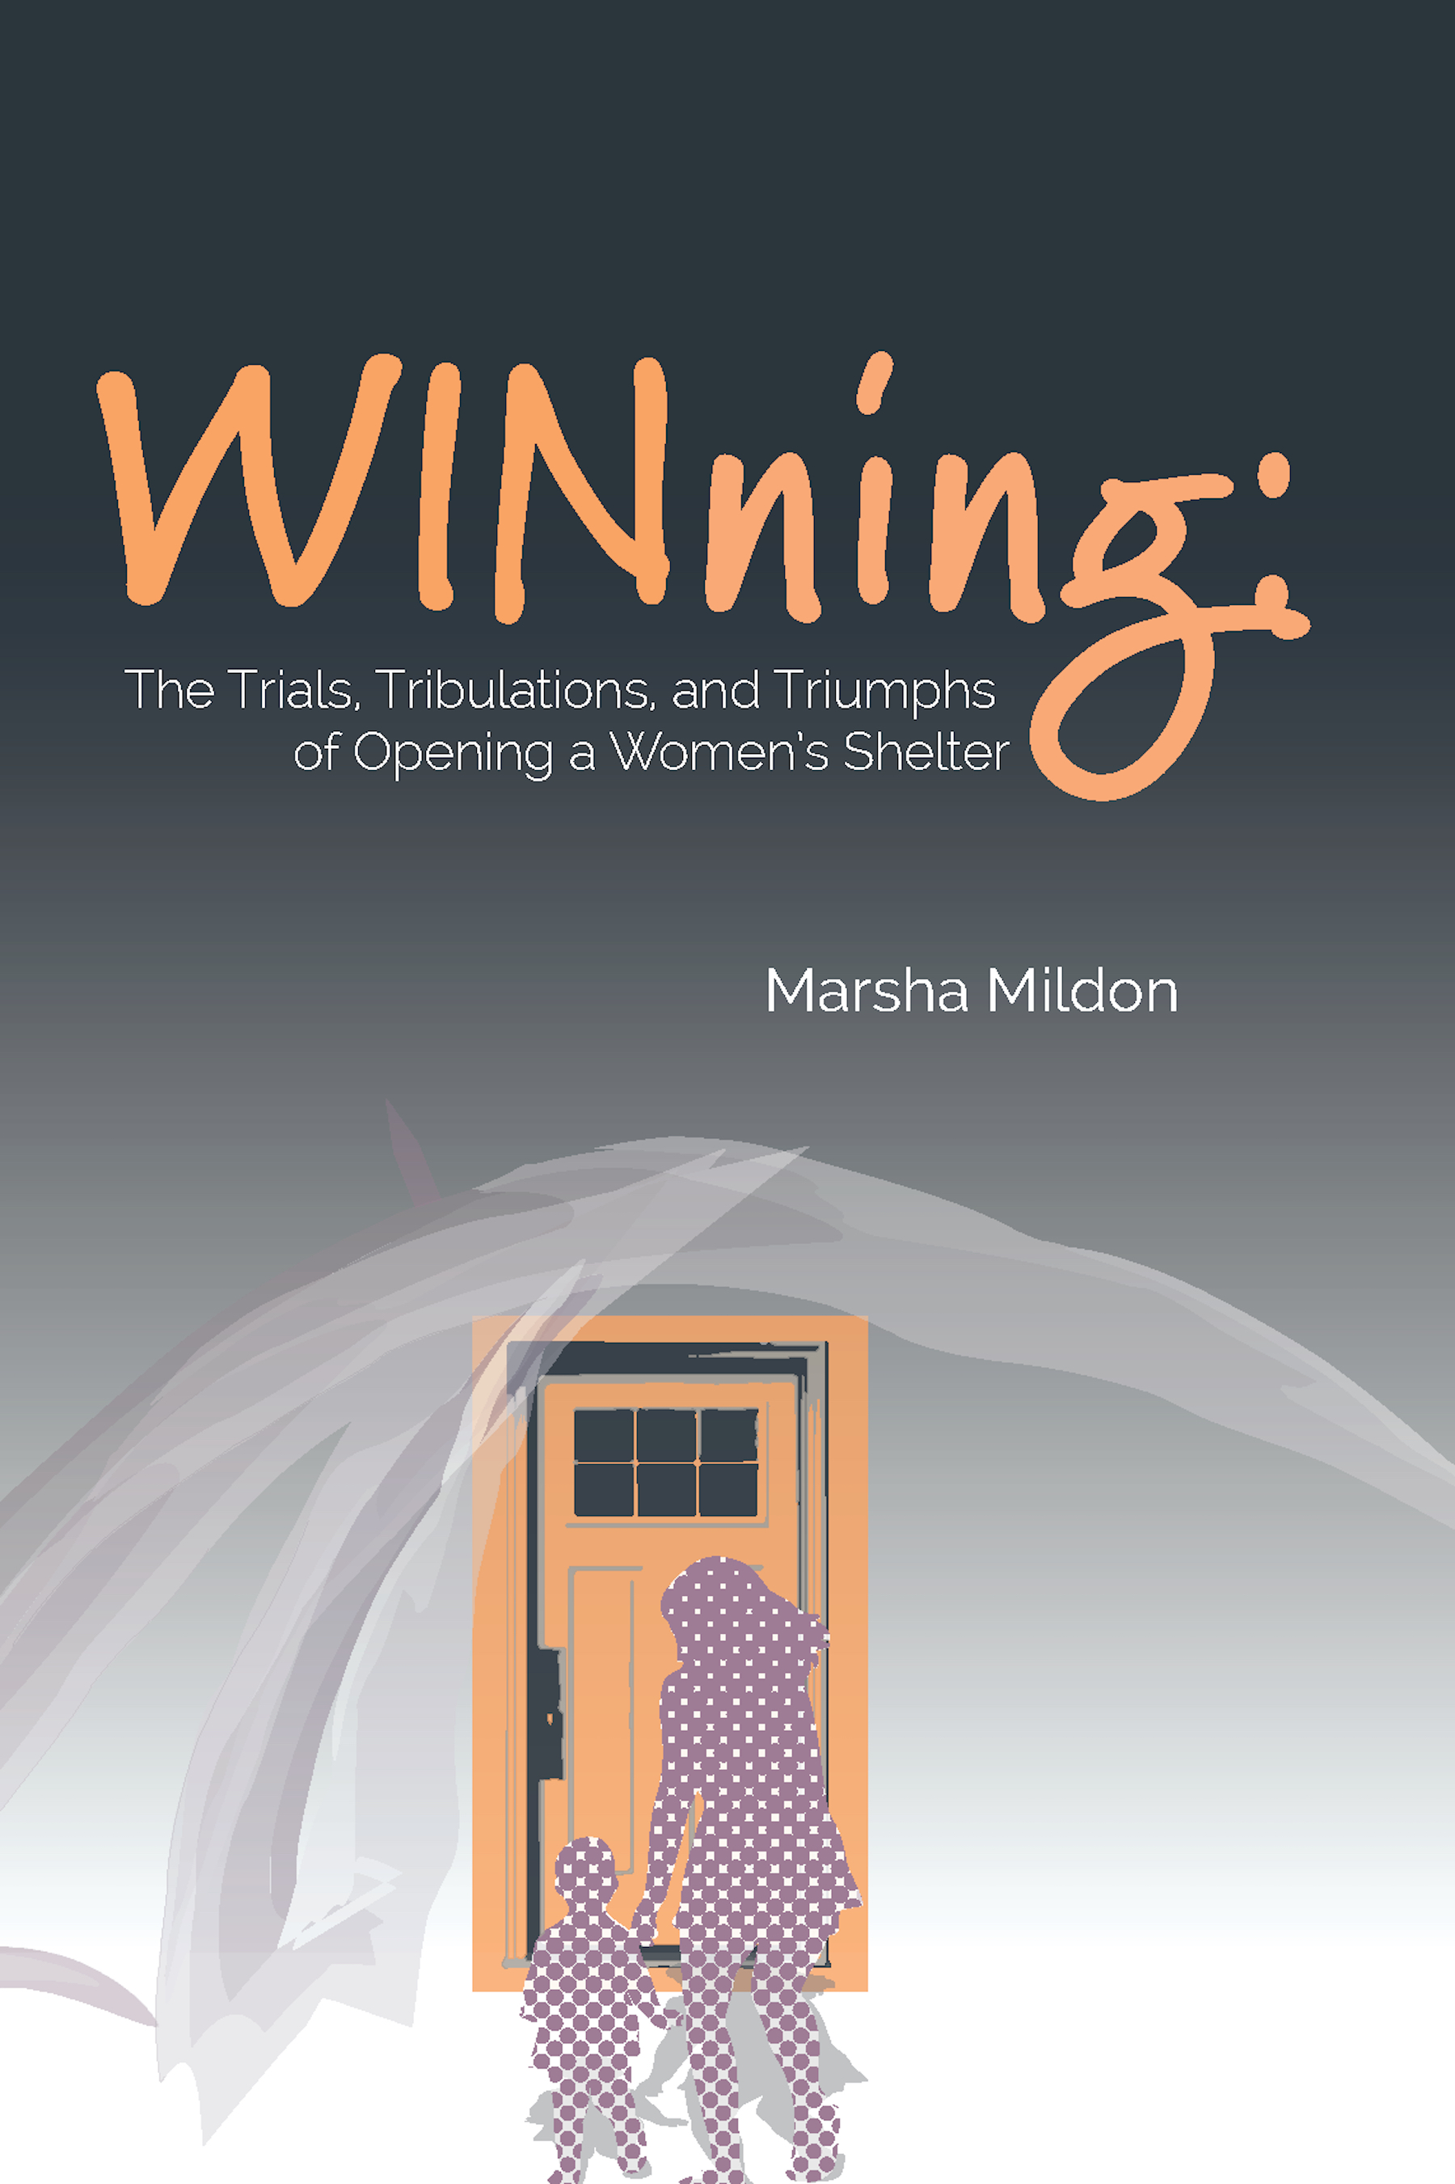-

**WINning: The Trials, Tribulations, and Triumphs   
 of Opening a Women's Shelter**

... *by Marsha Mildon*

in collaboration with Ardis Beaudry,

Rose-Marie McCarthy, Phyllis Ellis, Lynn Hannley

***ORDER FORM***

for information, see [www.enable.org/winning](http://www.enable.org/winning)

questions? [hfwin2020@gmail.com](mailto:hfwin2020@gmail.com)

# books @ $19.99 each (pick-up price, Edmonton area) _____ x $19.99 =$________

OR

# books @ $25.49 each (includes shipping in Canada) _____ x $25.49 =$________

**TOTAL =$________**

Contact information for pick-up/shipping:

Name __________________________________ e-mail ____________________ @ _____________

Address __________________________________ telephone ________-________-________

__________________________________ □ check box if phone # is cell/text-capable

City/Province ______________________________ Postal Code ______________________________

***Submit order***

e-mail: send order form as attachment to **hfwin2020@gmail.com**

and send ***e-Transfer*** to **hfwin2020@gmail.com**

postal mail: send order form and cheque (payable to “The Communitas Group”) to:



|  |  |
| --- | --- |
| **The Communitas Group (*WINning* book)**  #200, 12120-106 Avenue NW  Edmonton AB T5N 0Z2 |  |

*This project is supported by the Edmonton Heritage Council and the City of Edmonton.*